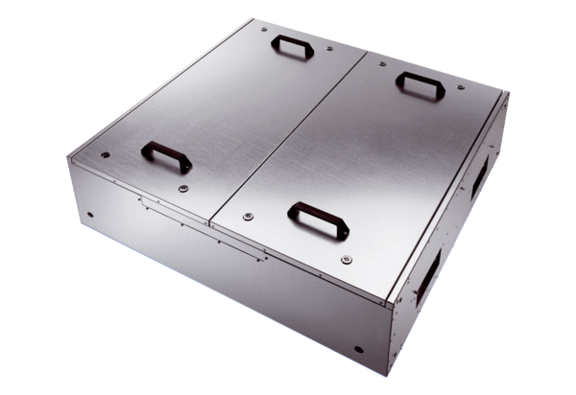Sound-insulated ventilation box KFD 6030Packing unit: 1 pieceRange: K
Article number: 0080.0962Manufacturer: MAICO

