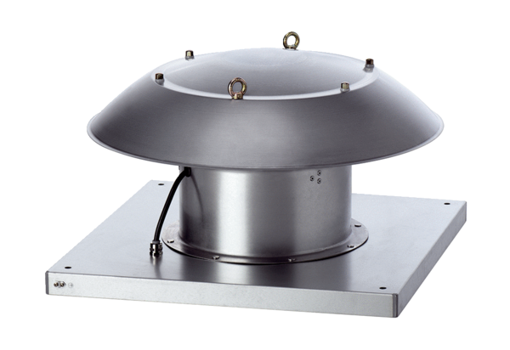Axial roof fan DZD 40/4 B Ex ePacking unit: 1 pieceRange: C
Article number: 0087.0805Manufacturer: MAICO

