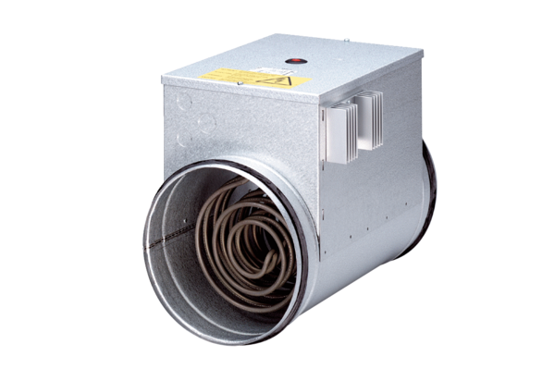Electrical air heater with controller DRH 35-12 RPacking unit: 1 pieceRange: C
Article number: 0082.0147Manufacturer: MAICO

