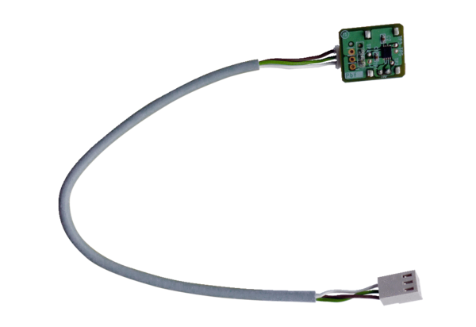Humidity sensor PPH-KPacking unit: 1 pieceRange: K
Article number: 0157.0200Manufacturer: MAICO

