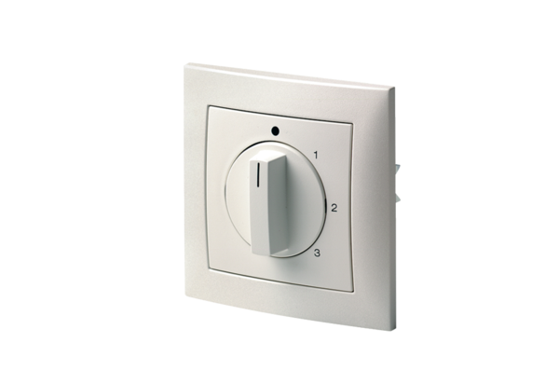3-step switch DS 3NPacking unit: 1 pieceRange: C
Article number: 0157.0186Manufacturer: MAICO

