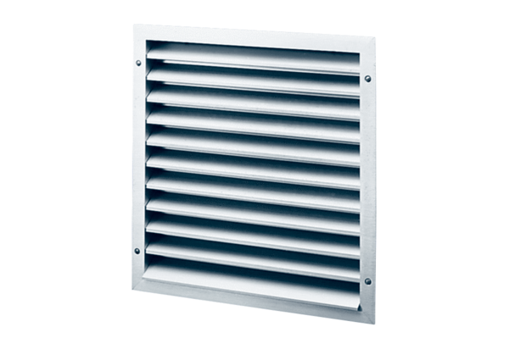External grille MLZ 30Packing unit: 1 pieceRange: C
Article number: 0151.0103Manufacturer: MAICO

