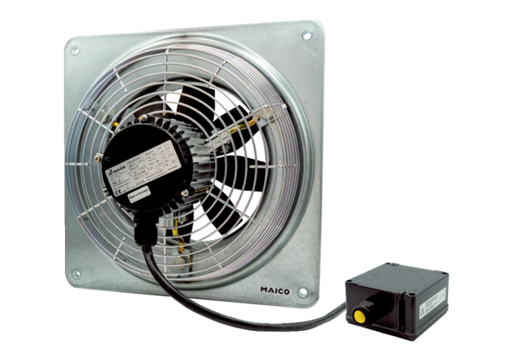Axial wall fan DZQ 30/2 B Ex ePacking unit: 1 pieceRange: C
Article number: 0083.0176Manufacturer: MAICO

