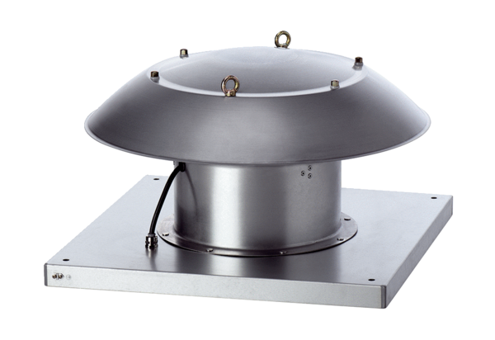Axial roof fan DZD 30/4 B Ex ePacking unit: 1 pieceRange: C
Article number: 0087.0799Manufacturer: MAICO

