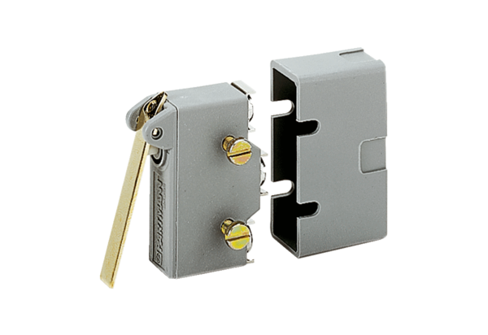Door contact switch TS 8Packing unit: 1 pieceRange: A
Article number: 0157.0120Manufacturer: MAICO

