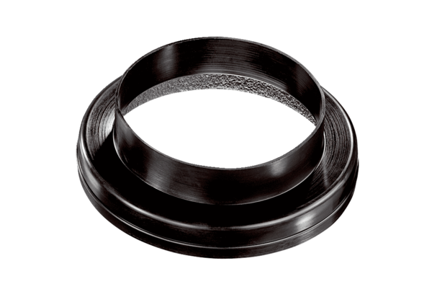Ventilation duct coupling MT-Ü160/150Packing unit: 1 pieceRange: K
Article number: 0059.0990Manufacturer: MAICO

