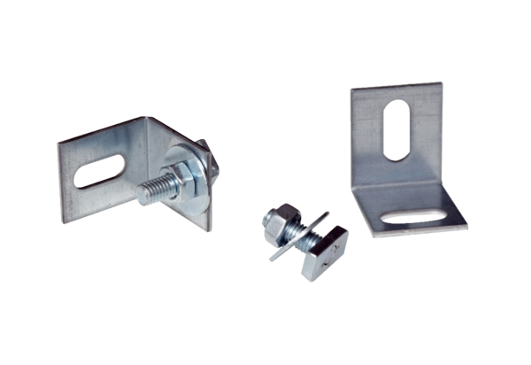Installation kit ER-MSPacking unit: 2 piecesRange: B
Article number: 0093.0603Manufacturer: MAICO

