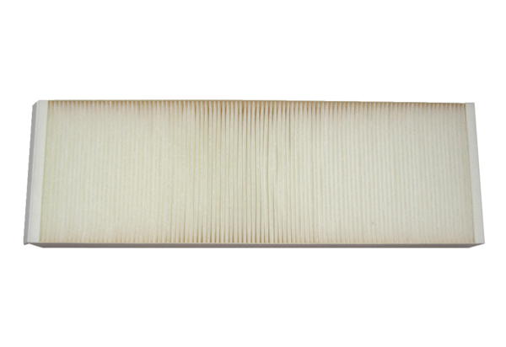Air filter, replacement WSF 320/470Packing unit: 1 pieceRange: K
Article number: 0092.0559Manufacturer: MAICO

