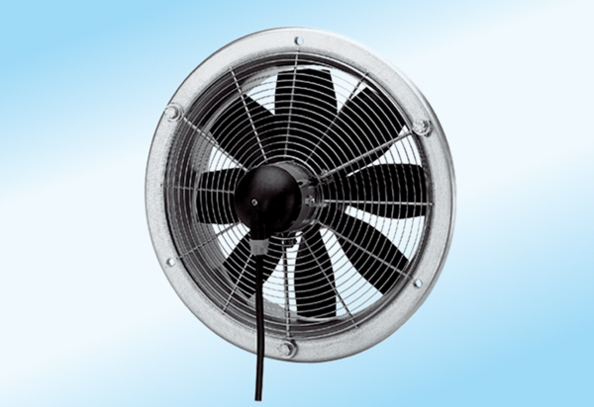Axial wall fan DZS 25/2 A-ExPacking unit: 1 pieceRange: C
Article number: 0094.0104Manufacturer: MAICO

