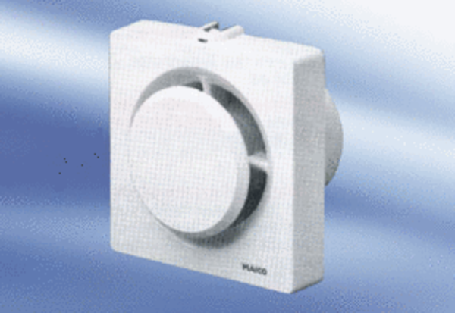Small room fan ECA 11-1Packing unit: 1 pieceRange:
Article number: 0080.0501Manufacturer: MAICO

