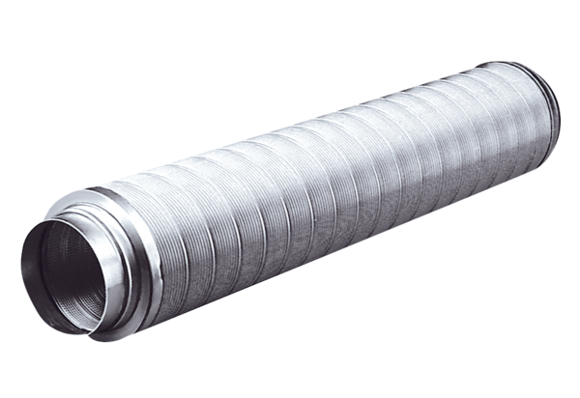Tubular sound absorber RSR 16Packing unit: 1 pieceRange: C
Article number: 0092.0314Manufacturer: MAICO

