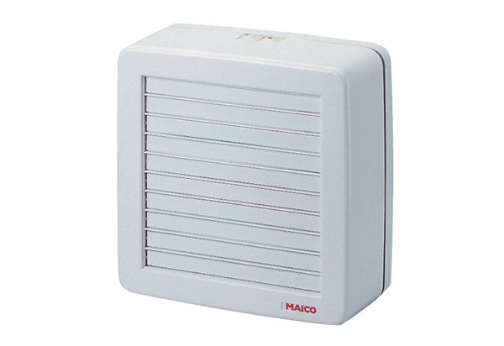Axial window fan EVR 31Packing unit: 1 pieceRange: C
Article number: 0080.0821Manufacturer: MAICO

