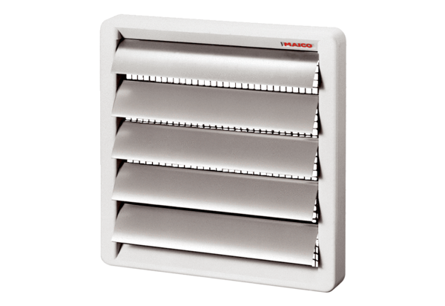Shutter, manual RS 25Packing unit: 1 pieceRange: C
Article number: 0151.0339Manufacturer: MAICO

