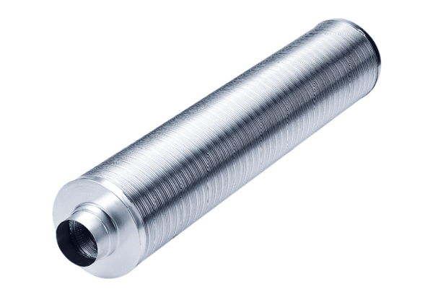Tubular sound absorber RSR 31/50Packing unit: 1 pieceRange: C
Article number: 0092.0329Manufacturer: MAICO

