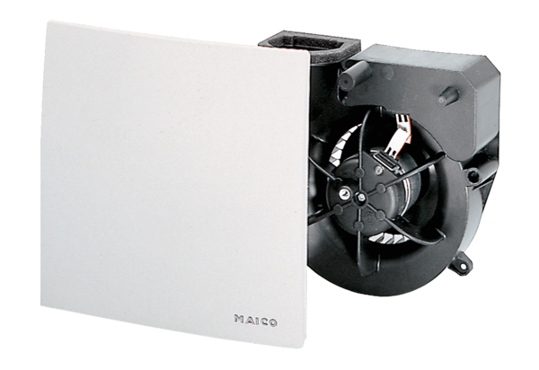Fan insert ER 100 HPacking unit: 1 pieceRange: B
Article number: 0084.0134Manufacturer: MAICO

