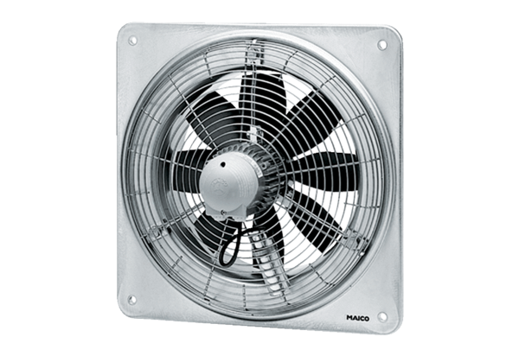Axial wall fan EZQ 25/2 BPacking unit: 1 pieceRange: C
Article number: 0083.0104Manufacturer: MAICO

