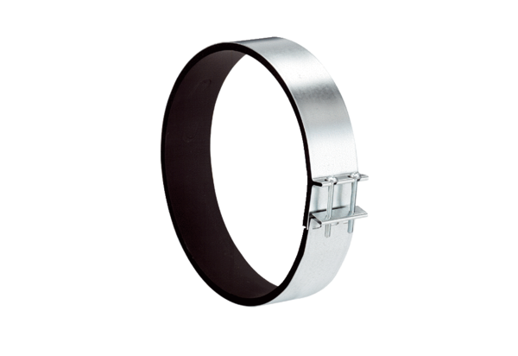Fixing cuff ELR 35Packing unit: 1 pieceRange: C
Article number: 0092.0115Manufacturer: MAICO

