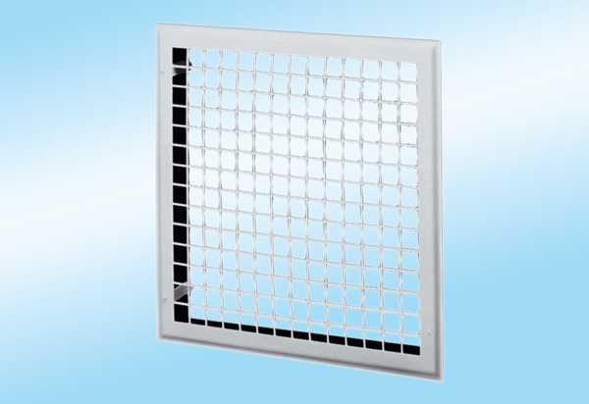Internal grille MLG 50Packing unit: 1 pieceRange: C
Article number: 0151.0066Manufacturer: MAICO

