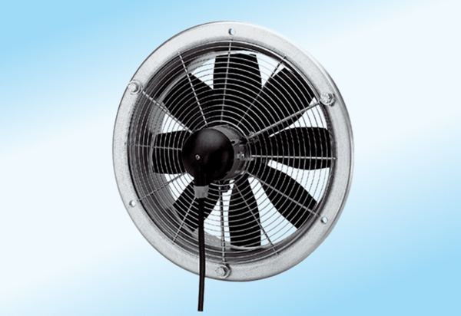Axial wall fan DZS 25/4 A-ExPacking unit: 1 pieceRange: C
Article number: 0094.0103Manufacturer: MAICO

