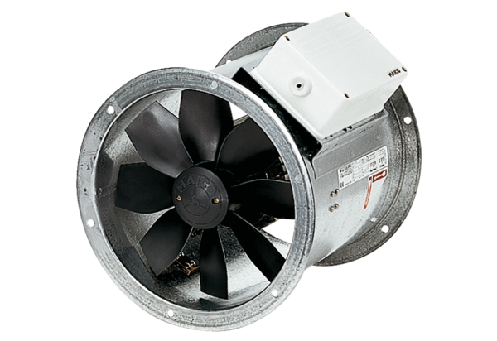Axial duct fan DZR 35/6 BPacking unit: 1 pieceRange: C
Article number: 0086.0026Manufacturer: MAICO

