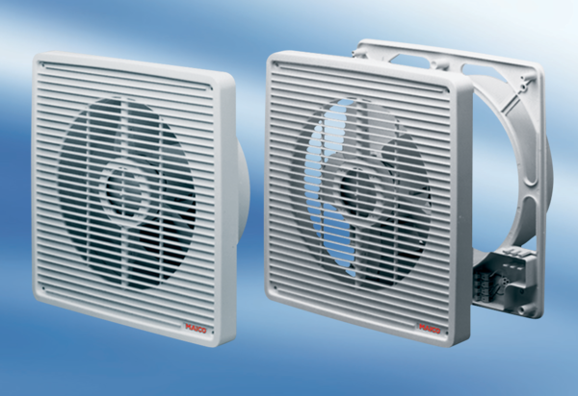Wall-mounted fan ENR 31Packing unit: 1 pieceRange: C
Article number: 0081.0306Manufacturer: MAICO

