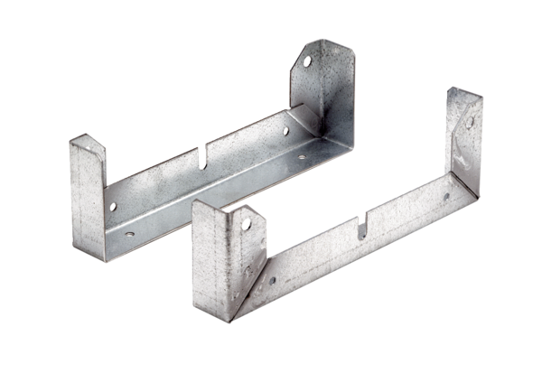Mounting foot FU 35Packing unit: 2 piecesRange: C
Article number: 0036.0072Manufacturer: MAICO

