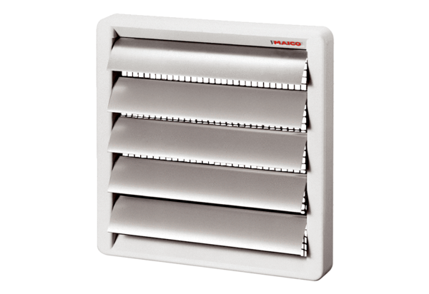Shutter AS 25Packing unit: 1 pieceRange: C
Article number: 0151.0331Manufacturer: MAICO

