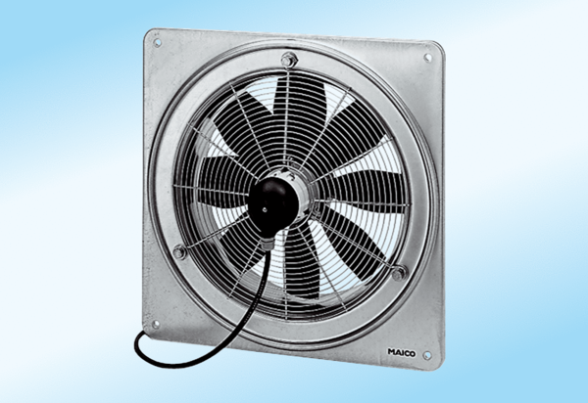Axial wall fan DZQ 30/6 A-ExPacking unit: 1 pieceRange: C
Article number: 0083.0765Manufacturer: MAICO

