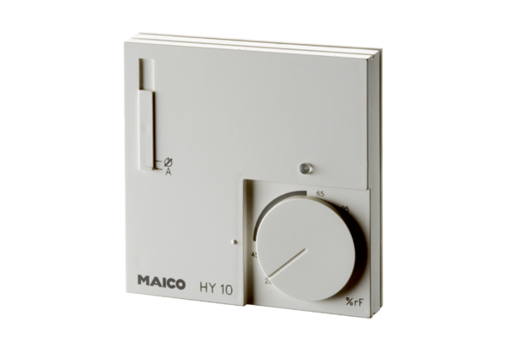Hygrostat HY 10 UPPacking unit: 1 pieceRange: C
Article number: 0157.0357Manufacturer: MAICO

