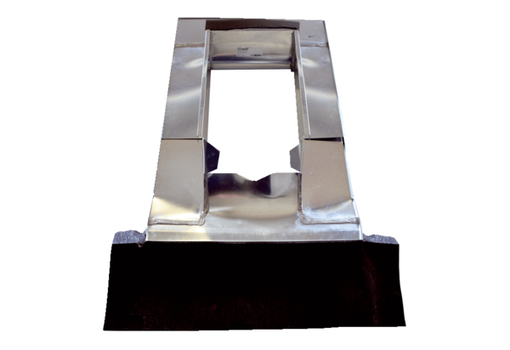Roof cover frame PP 45 DER 25-35Packing unit: 1 pieceRange: K
Article number: 0093.1316Manufacturer: MAICO

