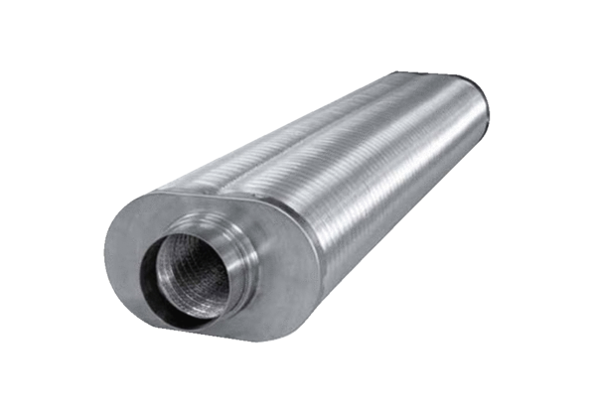Flat oval duct sound absorber RSOF 16/50Packing unit: 1 pieceRange: K
Article number: 0092.0532Manufacturer: MAICO

