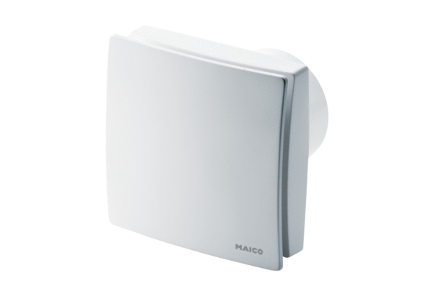Small room fan ECA 150 ipro KPacking unit: 1 pieceRange: A
Article number: 0084.0091Manufacturer: MAICO

