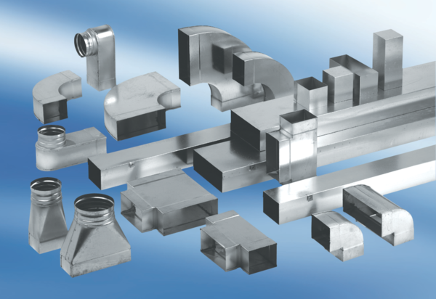Adaptor plug connector SVF80/100Packing unit: 1 pieceRange: K
Article number: 0055.0567Manufacturer: MAICO

