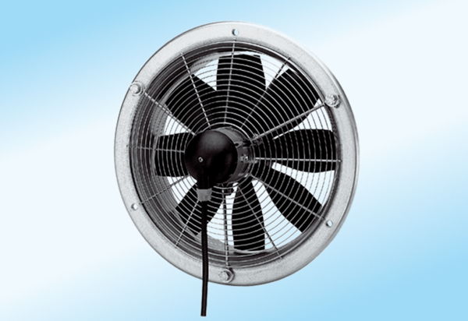Axial wall fan DZS 50/4 A-ExPacking unit: 1 pieceRange: C
Article number: 0094.0114Manufacturer: MAICO

