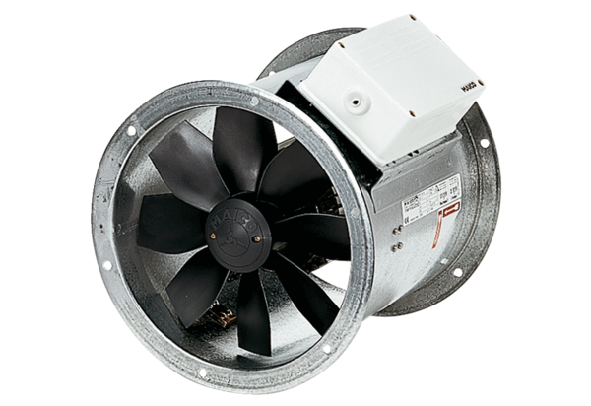Axial duct fan DZR 35/4 BPacking unit: 1 pieceRange: C
Article number: 0086.0027Manufacturer: MAICO

