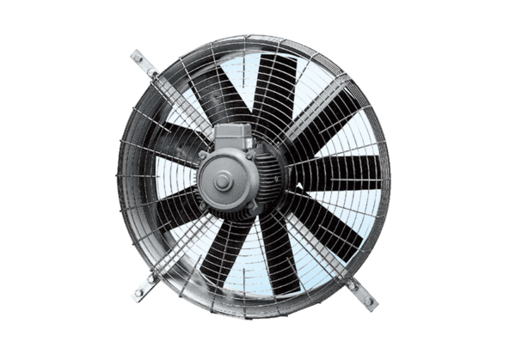Axial wall fan DZQ 71/6 APacking unit: 1 pieceRange: C
Article number: 0083.0642Manufacturer: MAICO

