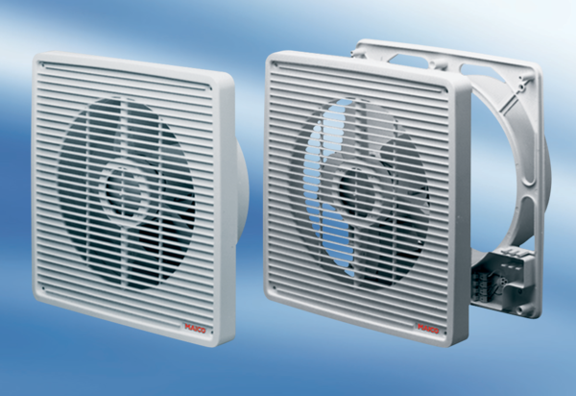Wall-mounted fan ET 20Packing unit: 1 pieceRange: C
Article number: 0081.0501Manufacturer: MAICO

