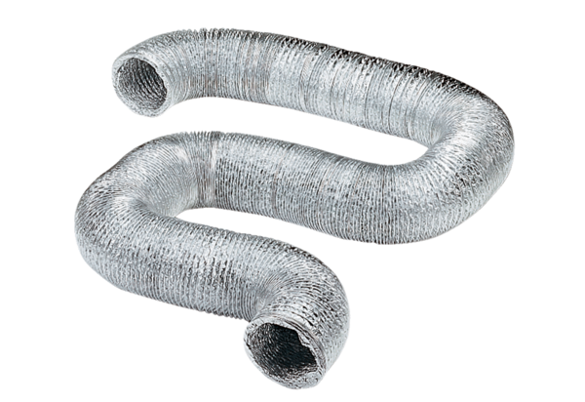Flexible aluminium duct AFR 125Packing unit: 1 pieceRange: C
Article number: 0055.0091Manufacturer: MAICO

