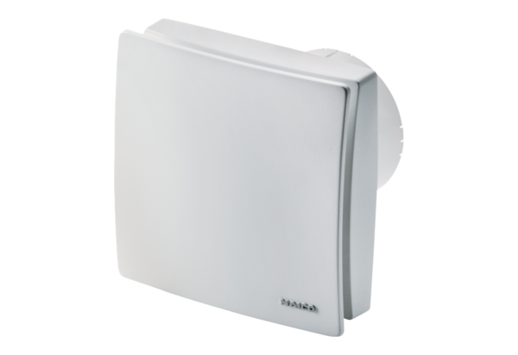Small room fan ECA 100 iproPacking unit: 1 pieceRange: A
Article number: 0084.0200Manufacturer: MAICO

