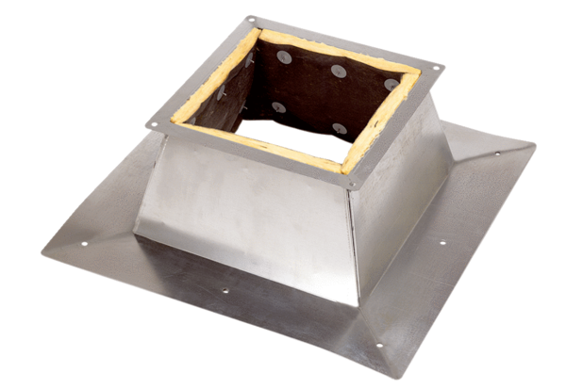Roof socket for flat roofs SO 30Packing unit: 1 pieceRange: C
Article number: 0093.0361Manufacturer: MAICO

