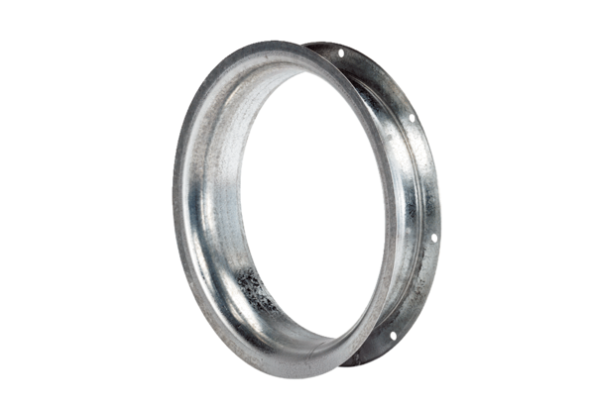Suction nozzle AD 35Packing unit: 1 pieceRange: C
Article number: 0180.0622Manufacturer: MAICO

