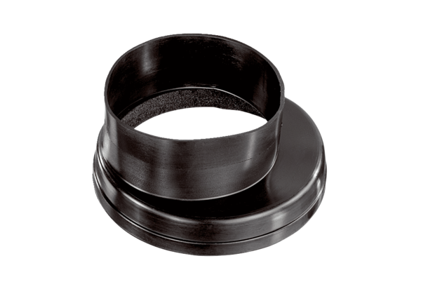Ventilation duct coupling MT-Üa125Packing unit: 1 pieceRange: K
Article number: 0059.0987Manufacturer: MAICO

