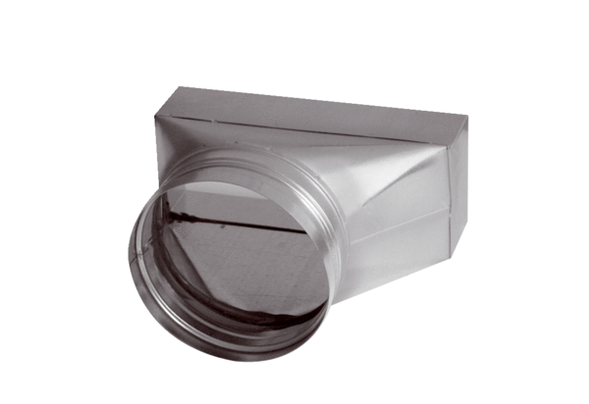Intermediate piece, asymmetric USAN70/170/80Packing unit: 1 pieceRange: K
Article number: 0055.0662Manufacturer: MAICO

