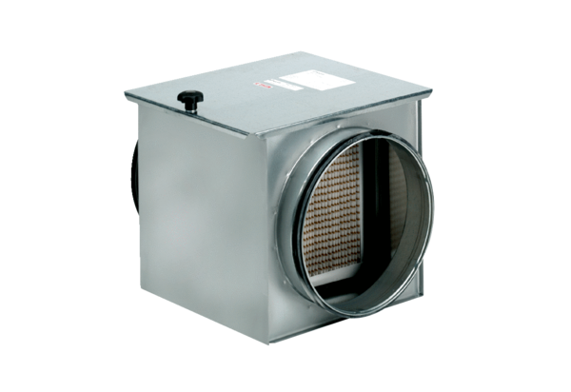Air filter TFE 25-5Packing unit: 1 pieceRange: C
Article number: 0149.0063Manufacturer: MAICO

