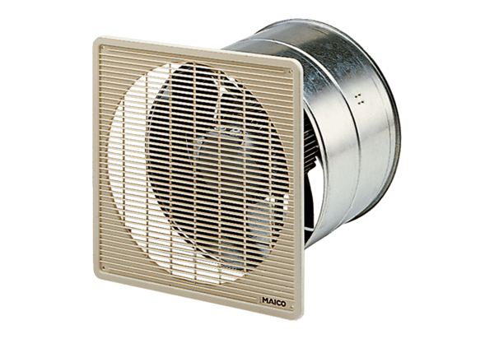Axial wall-mounted fan DZF 50/8 BPacking unit: 1 pieceRange: C
Article number: 0085.0110Manufacturer: MAICO

