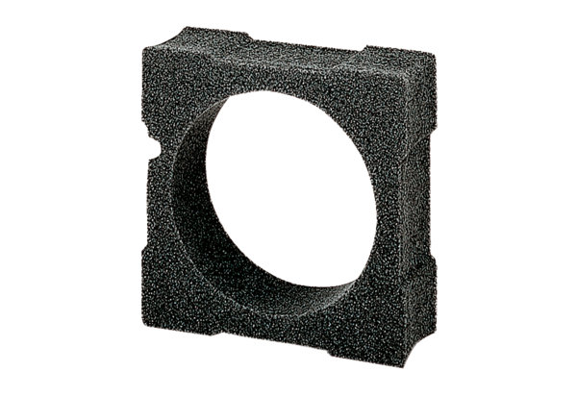Spacing frame ECA15-EMA16Packing unit: 1 pieceRange: A
Article number: 0092.0251Manufacturer: MAICO

