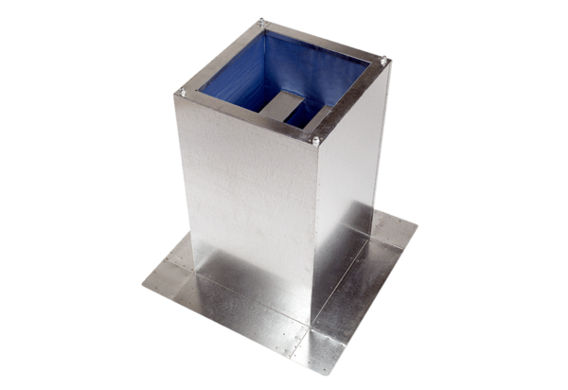Socket sound absorber SD 18Packing unit: 1 pieceRange: C
Article number: 0092.0337Manufacturer: MAICO

