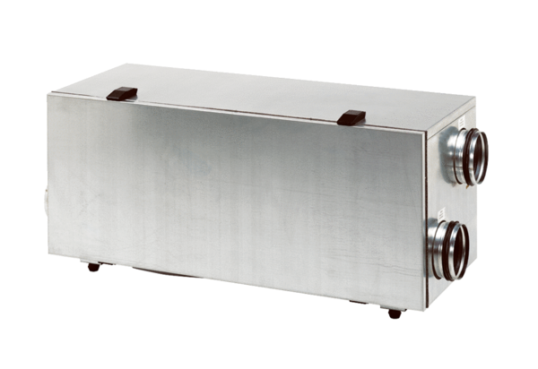Centralised ventilation unit WS 150 LPacking unit: 1 pieceRange: K
Article number: 0095.0058Manufacturer: MAICO

