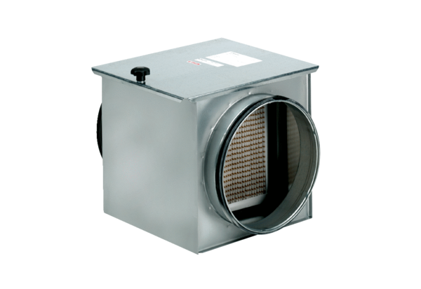Air filter TFE 16-7Packing unit: 1 pieceRange: C
Article number: 0149.0052Manufacturer: MAICO

