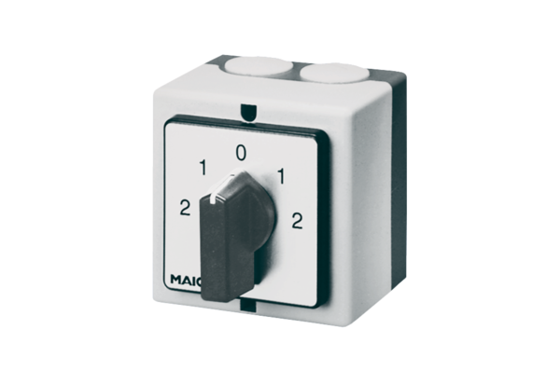Reversing switch, pole-changing switch WP 1Packing unit: 1 pieceRange: C
Article number: 0157.0105Manufacturer: MAICO

